A PRELIMENERY REPORT ON

AUTOMATED EMAIL TIME TABLE TO CALENDAR SCHEDULING


SUBMITTED TO THE VISHWAKARMA INSTITUTE OF INFORMATION TECHNOLOGY,
PUNE
IN THE PARTIAL FULFILLMENT OF THE REQUIREMENTS
FOR THE AWARD OF THE DEGREE

OF

BACHELOR OF TECHNOLOGY (COMPUTER ENGINEERING)

SUBMITTED BY
Sarthak Sarikar-22210794
Swaraj Gaikwad-22210249
Rajat Deshmukh-22210641
DEPARTMENT OF COMPUTER ENGINEERING

BRACT’S
VISHWAKARMA INSTITUTE OF INFORMATION TECHNOLOGY

SURVEY NO. 3/4, KONDHWA (BUDRUK), PUNE – 411048, MAHARASHTRA (INDIA).

Sr. No. |  | Title of Chapter |  | Page No.
01 |  | Introduction |  | 3
 | 1.1 | Overview |  | 3
 | 1.2 | Motivation |  | 3
 | 1.3 | Problem Definition and Objectives |  | 3
 | 1.4 | Project Scope & Limitations |  | 3
 | 1.5 | Methodologies of Problem solving |  | 4
02 |  | Literature Survey |  | 5
03 |  | System Design |  | 7
 | 3.1 | System Architecture |  | 7
04 |  | Project Implementatio2wn |  | 9
 | 4.1 | Overview of Project Modules |  | 9
 | 4.2 | Tools and Technologies Used |  | 9
 | 4.3 | Algorithm Details |  | 10
 |  | 4.3.1 | Algorithm 1 | 10
 |  | 4.3.2 | Algorithm 2 | 10
05 |  | Results |  | 12
 | 5.1 | Outcomes |  | 12
 | 5.2 | Screen Shots |  | 12
 | 5.3 | Confusion Matrix, Precision, Recall, Accuracy, Specificity ,Sensitivity All Graph
06 |  | Conclusions |  | 15
 | 9.1 | Conclusions |  | 15
 | 9.2 | Future Work |  | 15
 | 9.3 | Applications |  | 15

01. Introduction

1.1 Overview
The Automated Email Time table to calendar scheduling is a robotic process automation (RPA) solution developed using UiPath and Python to simplify and speed up the process of scheduling events into Google Calendar. In educational and organizational environments, timetables are often sent via email in Excel format, making manual calendar entry inefficient, error-prone, and time-consuming. The bot automates the task of retrieving timetable files from emails, reading and processing the data, creating calendar events, and ensuring accurate scheduling. It generates a seamless and reliable workflow that helps users save time and maintain organized calendars with minimal manual effort.
1.2 Motivation
The motivation behind this project stems from real-life scheduling challenges. Managing and updating calendars manually based on timetables received through email is a common issue in both educational institutions and corporate environments. Manual entry often results in delays, errors, and missed events. By using automation, we can bring consistency, accuracy, and speed into the scheduling process. This bot is especially useful for schools, colleges, and organizations that regularly handle large volumes of timetable updates and need an efficient way to maintain organized calendars.

1.3 Problem Definition and Objectives
Problem Definition:
Manual calendar entry from emailed timetables is slow, error-prone, and inefficient, requiring an automated solution for faster and more accurate scheduling.
Objectives:
- Automate the process of reading timetable Excel files received via email
- Extract and interpret timetable details such as event names, dates, times, and descriptions
- Create and schedule corresponding events automatically in Google Calendar
- Ensure accuracy and consistency in event creation to avoid manual errors
- Generate logs or reports of scheduled events for easy tracking and verification
1.4 Project Scope & Limitations
Scope:
- Retrieving emails and downloading Excel attachments containing timetable information
- Reading and processing the timetable data using UiPath and Python
- Creating calendar events with accurate titles, dates, times, and descriptions
- Ensuring error handling, logging, and optional notification after event creation
- Supporting scalability for use in educational institutions, corporate training schedules, and event management systems
- Excluding manual data entry and manual calendar updates, making the process fully automated and reliable
Limitations:
- The bot depends on a consistent email format and attachment type (Excel); unexpected email formats may cause errors.
- Only Excel (.xlsx/.xls) files are supported; PDF or other formats are not handled.
- Accuracy of calendar events depends on the correctness and completeness of the timetable data in the Excel file.
- Google Calendar API usage is subject to daily quotas and authentication limits.

1.5 Methodologies of Problem Solving
- Automation Tool: Used UiPath Studio for drag-and-drop automation
- Email Handling: Get Gmail Service to retrieve emails with timetable attachments
- File Processing: Read Range activity to extract timetable data from Excel files
- Event Creation: Python scripts integrated to interact with Google Calendar API for event scheduling
- Loops: For Each Row activity used to process each event entry from the Excel timetable
- Excel Integration: Data read and validated before event creation to ensure accuracy
- Logging: Message Boxes and Log Message activities used to monitor workflow during testing and execution.

02. Literature Survey
The concept of timetable management and event scheduling is not new, and several tools and techniques have been introduced over the years to simplify this task. However, most existing solutions require manual data entry or are part of complex, expensive management systems that aren't always flexible enough for handling bulk timetable updates via email. Our approach leverages UiPath, a powerful Robotic Process Automation (RPA) platform, combined with Python, to automate the entire process of reading timetable files from emails and scheduling events into Google Calendar. This solution provides a more flexible, cost-effective, and efficient method for automating calendar management.
Existing Methods:
- Manual Calendar Management:
  - Traditional methods rely on users manually adding timetable events to Google Calendar.
  - This process is prone to human error, time-consuming, and often results in duplicate or missed events.
  - While Google Calendar offers an interface for importing events, it lacks full automation for processing and scheduling data from Excel files directly.
- Third-Party Calendar Management Tools:
  - Tools like Zapier or Microsoft Power Automate allow users to integrate email systems with Google Calendar.
  - These solutions often focus on specific integrations, such as automatically adding events from Google Sheets.
  - They require complex setup, third-party subscriptions, and may not handle bulk timetable updates or Excel files with different formats.
- Custom-Built Solutions:
  - Some institutions or organizations use custom scripts or manual processes to automate calendar updates.
  - These solutions typically require significant development and maintenance efforts, along with coding knowledge.
  - They are not always flexible and often lack integration with existing platforms like email or Google Calendar API, making them harder to scale.

Our Literature Contribution:
This project demonstrates how Robotic Process Automation (RPA) using UiPath can be utilized as a lightweight and flexible solution for automating timetable management, as an alternative to expensive, complex, or manual methods. We explored the application of UiPath in automation and customized it to:
- Work with email attachments and download timetable files from local inboxes
- Support bulk timetable events from multiple Excel files or formats
- Automatically create Google Calendar events, ensuring accurate event scheduling
- Generate logs or reports for tracking and verifying scheduled events
- Optionally send confirmation emails or alerts to users after successful event creation

Learning from Past Research:
- Automation significantly reduces time spent on manual calendar updates by automating the extraction and scheduling of timetable events, leading to faster scheduling processes.
- Data-driven automation (such as using Excel files) can be efficiently used to process bulk timetable events, ensuring accuracy and speed in scheduling.
- Manual verification can still be incorporated after automation, allowing users to double-check or fine-tune event details, further reducing the workload while maintaining control over critical tasks.

03. System Design
The system design of the Automated Email Time table to calendar scheduling focuses on creating a clear, modular, and scalable structure for easy maintenance and effective automation. The project is built using UiPath workflows, which are divided into logically organized sequences and loops to ensure readability and flexibility.
- Input Layer – Handles retrieving emails, downloading timetable Excel attachments, and reading the file contents.
- Processing Layer – Extracts timetable details and processes them for Google Calendar event creation.
- Output Layer – Creates events in Google Calendar using the Google Calendar API
3.1 System Architecture
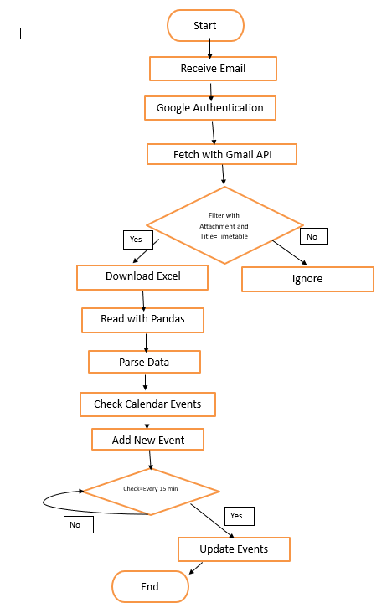

Summary of Flow:
- Receive an email.
- Authenticate with Google (for secure access).
- Fetch emails using the Gmail API.
- Filter emails that have an attachment and title containing "Timetable".
- If matching email found:
- Download the Excel attachment.
- Read the Excel file using Pandas.
- Parse the data for event details.
- Check existing calendar events.
- Add new events if needed.
- Every 15 minutes, check if updates are needed:
- If yes, update existing calendar events.
- End process if no updates are found.

04. Project Implementation
4.1 Overview of Project Modules
The project is implemented in UiPath Studio, using structured workflows and reusable sequences. The major modules are:
- Email Fetcher
Connects to Gmail using secure authentication and fetches emails with specific keywords in the subject and Excel attachments.
- Attachment Downloader
Downloads the Excel attachment from the filtered emails and stores it in a designated folder for processing.
- Excel Parser
Reads the downloaded Excel file using Pandas activities and extracts event-related details such as event name, date, time, and location.
- Calendar Updater
Connects to Google Calendar via API and either creates new events or updates existing ones based on the parsed data.
- Scheduler and Monitor
Checks for new or updated timetables at regular intervals (every 15 minutes) to ensure the calendar stays updated.

4.2 Tools and Technologies Used

Tool / Technology | Purpose
UiPath Studio | Automation platform
Python | Used for interacting with Google Calendar API for event creation
Google Calendar API | API for adding events into Google Calendar automatically
Excel (xlsx) | File format used for storing timetable data
Gmail | Email platforms used for receiving timetable files and sending reports
UiPath Activities | Activities like Get Mail Messages, Read Range, and Write Range used in UiPath automation
Google API Client | Python library used for authentication and event creation in Google Calendar

4.3 Algorithm Details
The logic is implemented using standard API integration, file processing, and data parsing techniques within UiPath’s visual programming model.
4.3.1 Google Services Authentication
Goal: Authenticate and authorize access to Gmail and Google Calendar services.
Steps:
- Call GoogleServices.get_service to check for an existing valid token.
- If no valid token is found, prompt the user to complete the Google OAuth authorization flow.
- Save the authentication token for future sessions to avoid repeated logins.
- Establish secure connections to both Gmail and Google Calendar APIs.
4.3.2 Email Fetching and Attachment Downloading
Goal: Fetch emails with timetable attachments from Gmail inbox.
Steps:
- Use the Gmail API to search for new/unread emails containing keywords like "Timetable" in the subject.
- Validate the presence of an Excel (.xlsx) attachment.
- Use get_attachment function to securely download the attachment.
- Save the attachment using the save_tt function with a filename containing metadata (department, division, academic year).
4.3.3 Excel Data Extraction
Goal: Parse the timetable details from the downloaded Excel attachment.
Steps:
- Open the saved Excel file using extract_data_from_xlsx.
- Validate that required headers like "DAY," "TIME," and division names (e.g., SY A, SY B) exist.
- For each day, extract:
  - Subject names
  - Start time and end time (handle various formats like "9.00 am - 10.00 am")
- Create structured entries mapping subjects to their corresponding time slots.
4.3.4 Timetable Structuring
Goal: Organize extracted timetable data into a structured format.
Steps:
- Create a list of dictionaries where each dictionary represents a timetable entry.
- Each entry contains fields like:
  - Day
  - Start Time
  - End Time
  - Subject Details
- Prepare the structured data for calendar insertion.
4.3.5 Google Calendar Update Automation
Goal: Insert or update calendar events based on the extracted timetable data.
Steps:
- For each timetable entry:
  - Check if an event already exists for that day and time.
  - If not, create a new event using the Calendar API.
  - If an event exists, update it if necessary.
- Handle time zone and recurrence settings if required.
- Save changes and synchronize the calendar.
4.3.6 Background Automation and Monitoring
Goal: Ensure the system operates continuously and handles updates automatically.
Steps:
- Periodically fetch active users from the database.
- For each user:
  - Fetch new emails every 15 minutes.
  - Download and process new timetable attachments if found.
  - Update Google Calendar events accordingly.
- Handle token expiration gracefully by refreshing tokens when needed.
- Log errors like invalid Excel formats or API failures for review.

05. Results

5.1 Outcomes
The Automated Email Time table to calendar scheduling was successfully implemented and tested using sample emails with timetable attachments. The project was able to:
- Automatically fetch and filter relevant emails based on subject and attachment criteria.
- Download and read Excel attachments using Pandas.
- Parse event data such as event name, date, time, and location.
- Compare and update calendar events based on new or changed information.
- Maintain a consistent update cycle by checking for changes every 15 minutes.
Key Output:
- Accurate calendar updates with fields such as:
Event Title, Date, Start Time, End Time, Location, Description
- An automated process that significantly reduced manual scheduling efforts, ensured timely updates, and minimized human error.

5.2 Screen Shots
The following screenshots should be inserted in the report:
- UiPath Workflow Design:
  - Screenshot of the Main Sequence and For Each loops
  - Highlight key activities like Read Excel file, Extract Data, Write Range, Create event.
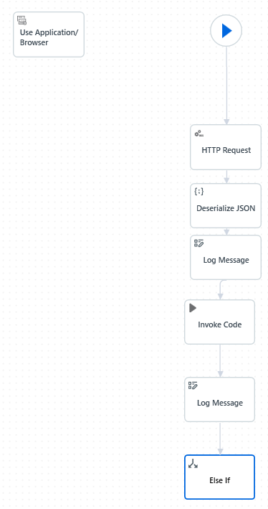 | 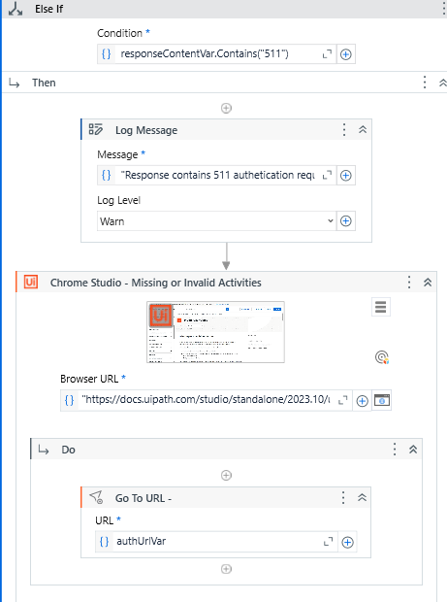

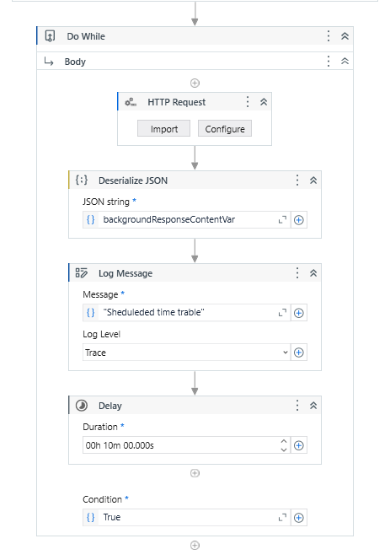 | 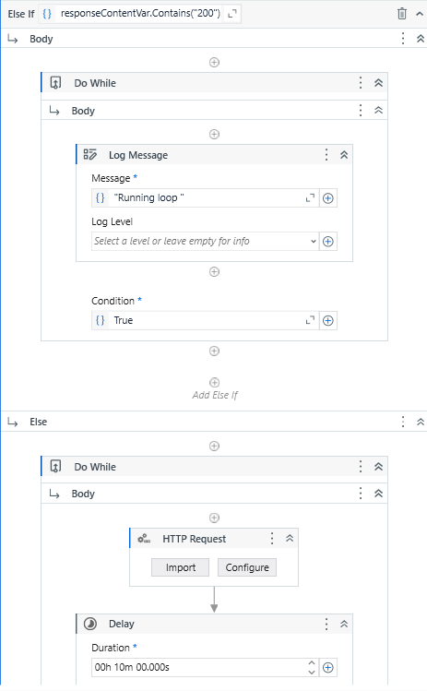

- Output:
  - Screenshot of the final output showing event are created in Google Calendar:
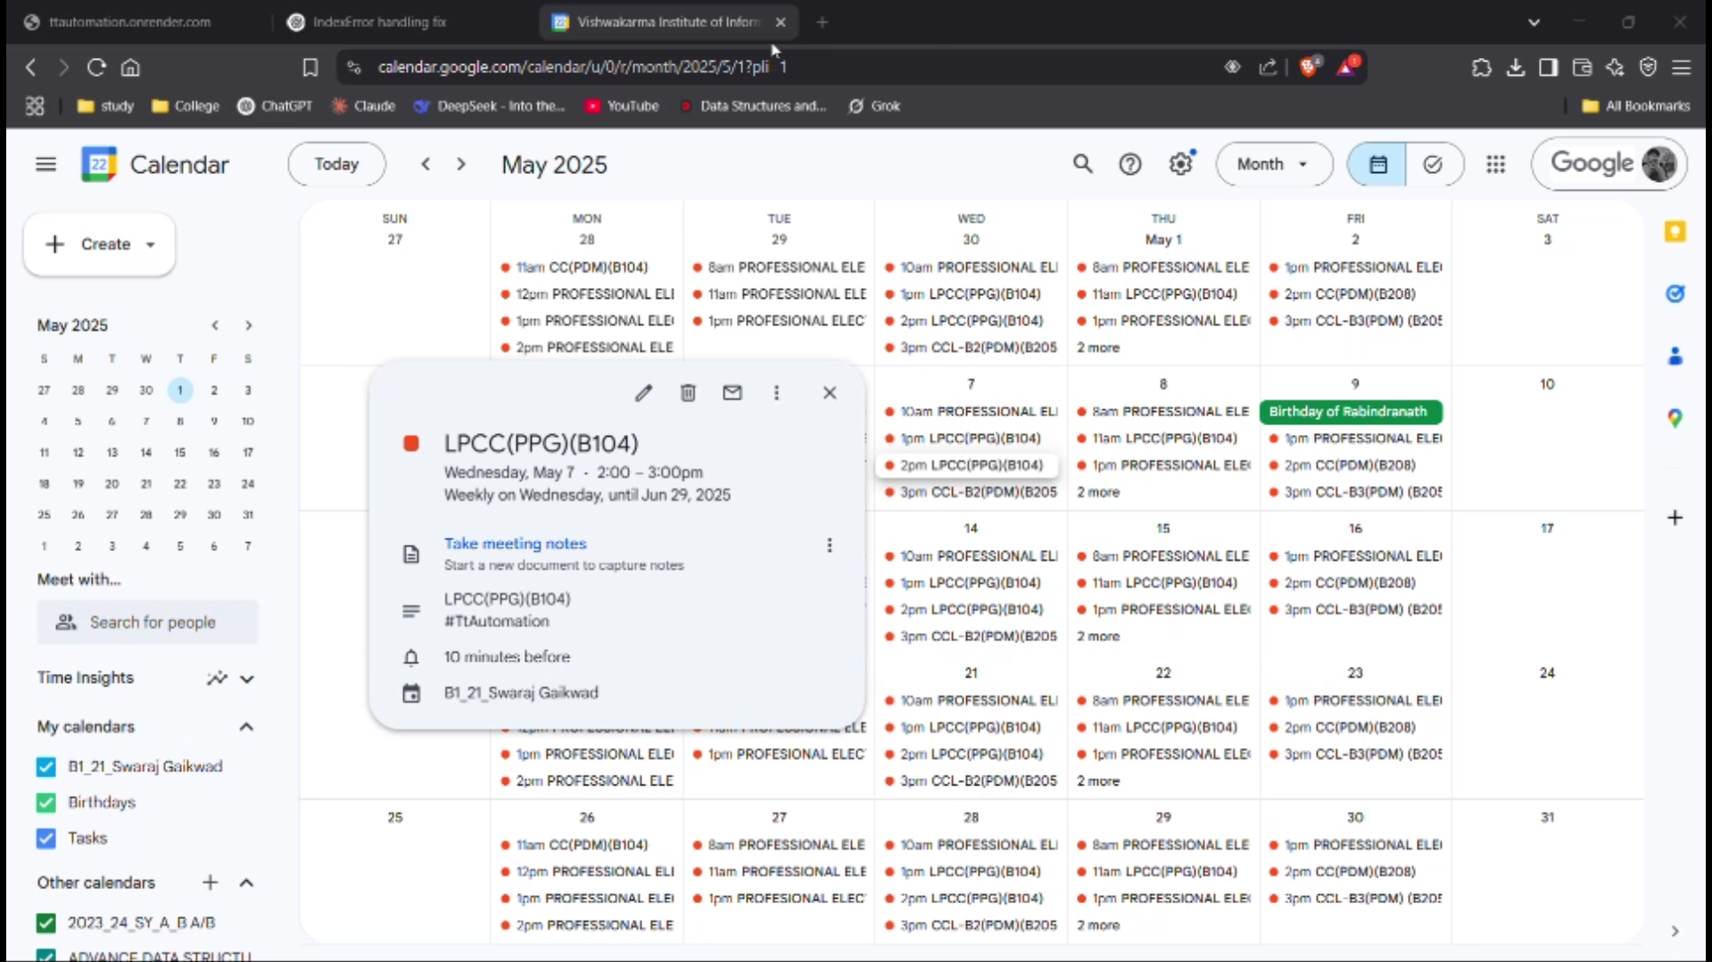

- Email with Attachment:
  - Screenshot showing email draft
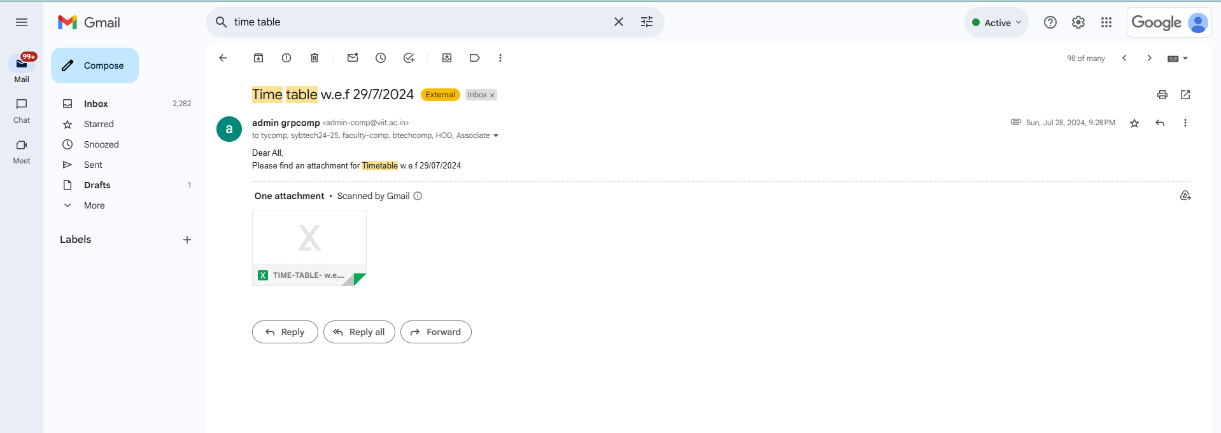

06. Conclusions
6.1 Conclusions
The Automated Email Time table to calendar scheduling successfully streamlines the process of updating calendar events based on email attachments. The bot fetches emails, filters for specific timetable files, parses the data, and updates calendar events automatically. Key takeaways from the implementation include:
- The bot efficiently automates the extraction and processing of event data from Excel attachments, eliminating the need for manual calendar management.
- It ensures a consistent and accurate update of calendar events based on the latest timetables received via email.
- The integration with Google Calendar provides real-time synchronization, enhancing scheduling reliability and reducing missed updates.
- The system has significantly saved time and reduced human errors, helping users stay organized and ensuring timely event management.
6.2 Future Work
While the current version of the project effectively automates calendar updates from email attachments, there are several opportunities for future enhancements:
- Machine Learning Integration: Incorporating machine learning models could help the bot intelligently categorize events, predict recurring patterns, or automatically detect changes in timetables with higher accuracy.
- Enhanced Data Parsing: Extending the parsing capabilities to handle more complex or differently formatted Excel files, including multiple sheets, merged cells, or dynamic tables.
- User Interface Development: Building a user-friendly dashboard where users can manually review, approve, or edit extracted events before they are pushed to the calendar.
- Real-time Notifications: Adding features like email or mobile notifications for newly added or updated events to improve user engagement and awareness.
- Integration with Other Calendar Systems: Expanding compatibility beyond Google Calendar to include Microsoft Outlook, Apple Calendar, or enterprise scheduling tools to serve a broader range of users.
6.3 Applications
The primary application of the Automated Email Time table to calendar scheduling is in event scheduling and management. However, it can be extended to various other domains, including:
- Educational Institutions: Automating the update of academic calendars based on emailed schedules for classes, exams, or events, reducing administrative workload.
- Corporate Environments: Assisting teams by automatically updating meeting schedules, training sessions, or project timelines received via email attachments.
- Healthcare Systems: Managing appointment schedules, staff shifts, or training events based on regularly updated Excel sheets sent by hospital administration.
- Event Management Companies: Automatically populating event calendars with client-provided itineraries and schedules, ensuring accurate and timely updates without manual entry.

